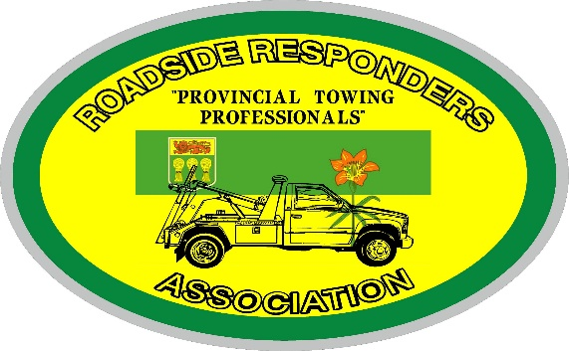
RRAS Tow Show 2022
Sponsorship Opportunities

Light/Medium Duty Beauty $250.00 1st place 2nd place
Flatbed Beauty $250.00 1st place 2nd place
Heavy Duty Beauty $250.00 1st place 2nd place
Tractor Beauty $250.00 1st place 2nd place
Voter’s Choice Award $250.00
Specialty Antique Truck
Year 2000 and older $250.00

- Welcome Reception $1,000.00
- BBQ and Light Show $2,500.00 5 slots at $500.00 or $2,500 for one sponsor
- Banquet and Entertainment $5,000.00 2 slots at $2,500.00 or $5,000 for one sponsor
There are other areas where sponsorship would be appreciated as well! Just ask us or suggest to us!
Please complete the above form and email to roadsideresponderssask@gmail.com as soon as possible. Sponsorships must be paid in full and sent in with the order form and are on a first come, first serve basis.
Please make cheques payable to Roadside Responders of Saskatchewan
Box 7341, Saskatoon, SK S7K 4J3

Name of Company: _______________________________________________________
Name of Contact: _________________________________________________________
Contact Phone Number: ______________________ Fax:________________________
Email_____________________________________________________________
Credit Card Information _____Visa _____ MC ______Am Ex _____Etransfer
Card # ____________________________________________ Expiry Date:____________
Name on Card:______________________________________CVV # _______________

