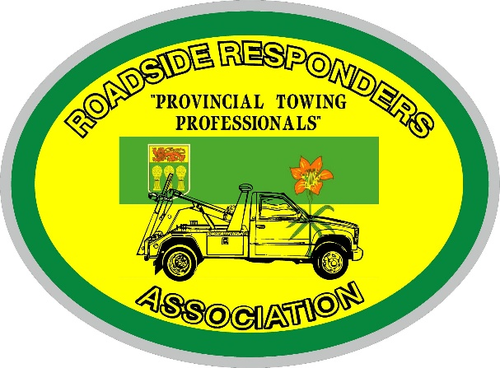
Roadside Responders Association of Saskatchewan
Tow Show 2022
September 9 – 11th
Saskatoon Inn, 2002 Airport Drive, Saskatoon
REGISTRATION for ATTENDEES
(There is no charge, but you must register prior to attending)
Company Name: _____________________________________________________
Attendees: 1._________________ 2. ___________________ 3. _______________
4._________________ 5.___________________ 6.________________
Email:_____________________________________________________________
Phone #:_________________________
Badges will be given out at Registration (Please ensure all of your attendees are registered)
Welcome Reception & Registration: Thursday September 8th, 6 – 10 pm
Take a load off and kick back! The RRAS Welcome Reception is the perfect way to relax after travelling, meet up with old friends and make some new ones as we get ready to enjoy the RRAS tow show.
Upon registration you will be issued more information on the Beauty Pageant and other events for the weekend.
Special room rates available at the Saskatoon Inn for the Tow Show.
Reference: Tow Show - Roadside Responders
Phone: (306)-242-1440 then press option 1
Online Code: https://reservations.travelclick.com/6876?groupID=3295930
Cut-off Date: August 9, 2022 (after this date you will still get the room rate just no guarantee of rooms)

Please email Tow Show registration to roadsideresponderssask@gmail.com or fax to 306-931-1607

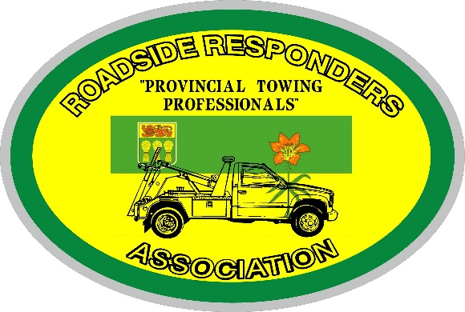
Roadside Responders Association of Saskatchewan
TOW SHOW 2022
September 9 – 11th
Saskatoon Inn, 2002 Airport Drive, Saskatoon
Focus is on visiting & professional promotion of the industry.
Sharing Ideas & Stories
Visit your dealer’s booths to learn how they support product service to the
Towing Industry – See what’s new!

For this reason there will be no time consuming driving competitions. We will have an area set up where will have unlock demonstrations where you may all participate and show others your tricks of the trade. There will be one unlock kit prize to give away at the Banquet to all whom participate. Make sure you get your name in the draw!
Make sure you reserve the number of rooms you will be needing and use the RRAS Tow Show reference to book.
Let us know the number and type of truck you will be entering in the Beauty Contest
_________More information on the Beauty contest to follow ___________________________
Banquet Tickets $60.00 for RRAS Members. ________ $75.00 for Non Members ________
A great meal, Live Entertainment, Prizes and a great chance to visit with other towers & reps.

Itinerary for the weekend:
Thursday, Sept. 8th 7:00pm – 10:00pm Registration, Welcome Reception and Exhibitor Move In
Friday, Sept.9th 9:00 am – 5:00 pm Trade Show and Special Events
Evening – BBQ and Tow Truck light show
Saturday, Sept. 10th 9:00am – 4 pm. Trade Show and Special Events
Evening - 6:00 pm – 12:00am Banquet with live entertainment TBD
Sunday, Sept. 11th 9:00 am – 12:00 pm Trade Show 12:00pm Exhibitor Tear Down

