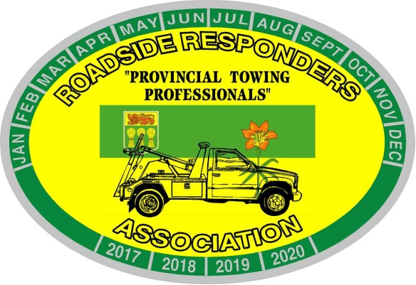
Roadside Responders Association of Sask. Inc.
Box 7341
Saskatoon, Saskatchewan, S7K 4J3
roadsideresponderssask@gmail.com

March 2021 Tow Tips
Winch Tips;
Free Wheel – To prevent un-wanted repairs to your winch, whether its on a wrecker or a carrier; once you have free wheeled the winch to get the hook to where you want it, ALWAYS back the winch off once it engages to ensure full engagement of the winch; OR use reverse until it locks into gear.
Remember, never free wheel under load. If you last used the winch under load, back it off if even an inch for easier release into free wheel.
NEVER use the winch on a carrier as a point of security. The winch is meant to load the carrier only, not as a securement point. See NSC 10 for 4 corner tie down. Using the winch as a tie down creates shock load to the winch.

Tow Tips are provided as suggested ideas or reminders and are not meant to take the place of your company policies or S.O.P. They come from the heart of someone that has paid for mechanical mistakes while learning, and years of being on scene figuring out what worked. They are not meant to disrespect any of your current practices.

