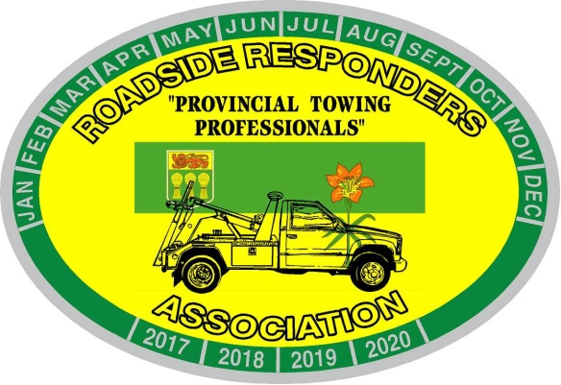
Roadside Responders Association of Sask. Inc.
Box 7341
Saskatoon, Saskatchewan, S7K 4J3
roadsideresponderssask@gmail.com

March 2021 Tow Tips
Pylons;
Use pylons every chance you get. Carry a minimum of 4 on every truck. Take the time to set them out. The general motoring public has been inundated with information about “construction zones” – “the cone zone” They are wired to see a pylon and know something is up.
ALWAYS work the ‘non-traffic’ side controls on your recovery vehicle. Passenger side if parked with the flow of traffic – drivers’ side if facing traffic.
Shut your headlights off when facing traffic on the shoulder. Confused drivers see headlights and want to go to the right of them.
Have you ever done this? Set your pylons out and watch 3 cars pass your scene. Put the pylons away and watch the next 3 cars pass your scene. Any difference?

Tow Tips are provided as suggested ideas or reminders and are not meant to take the place of your company policies or S.O.P. They come from the heart of someone that has paid for mechanical mistakes while learning, and years of being on scene figuring out what worked. They are not meant to disrespect any of your current practices.

