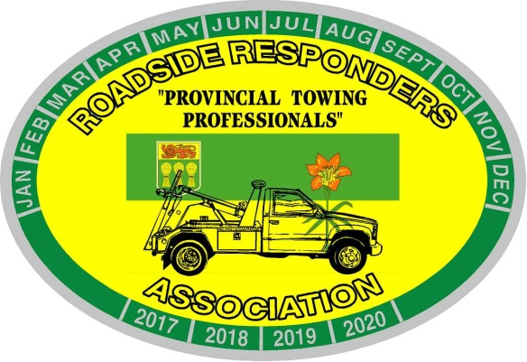
Roadside Responders Association of Sask. Inc.
Box 7341
Saskatoon, Saskatchewan, S7K 4J3
roadsideresponderssask@gmail.com

June 2021 Tow Tips
Wheel Lift vs Frame Forks;
When towing a pick up or a van that has a hidden hitch, do you scoop it; or use your frame forks? Let me ask you this – when you help someone carry a picnic table, do you grab the end of the table; or reach a foot into it to lift? The same logic applies to the option of towing by use of frame forks. The casualty weighs less at the hitch than it does at the axle. Less wheel-lift extension makes more front axle weight on your wrecker; which creates safer steering, and less wear and tear on your pins and bushings; thus, giving your more tows before a wheel lift rebuild.
If you choose the frame fork option, always use two forms of securement such as an omega ring and boomer and secondary safety chains.

Tow Tips are provided as suggested ideas or reminders and are not meant to take the place of your company policies or S.O.P. They come from the heart of someone that has paid for mechanical mistakes while learning, and years of being on scene figuring out what worked. They are not meant to disrespect any of your current practices.

