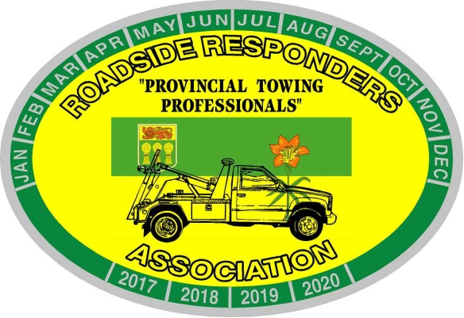
Roadside Responders Association of Sask. Inc.
Box 7341
Saskatoon, Saskatchewan, S7K 4J3
roadsideresponderssask@gmail.com

May 2021 Tow Tips
Education - Education – Education!
If you find some free time between trips; take an on-line course. Wreckmaster has several that can be done over a short period of time. Even if they are ‘repeat’ courses, a refresher can be a great reminder. Some of the Saskatchewan based courses that we already pay for through our WCB expenses can be found at the following websites.
Motor Safety Association under MSA on line training
www.motorsafety.ca
WorkSafe Saskatchewan under education – on line courses
www.worksafesask.ca

Driving defensively – eye; hand; back -office ergonomics. Many of these courses are meant to help keep us safe at work.

Tow Tips are provided as suggested ideas or reminders and are not meant to take the place of your company policies or S.O.P. They come from the heart of someone that has paid for mechanical mistakes while learning, and years of being on scene figuring out what worked. They are not meant to disrespect any of your current practices.

