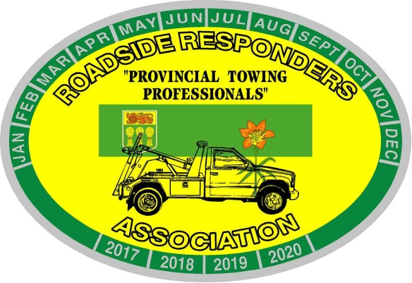
Roadside Responders Association of Sask. Inc.
Box 7341
Saskatoon, Saskatchewan, S7K 4J3
roadsideresponderssask@gmail.com

2021 TOW SHOW
Date: September 17 – 19th, 2021
Location: Saskatoon Inn, 2002 Airport Drive, Saskatoon, SK, Canada S7L 6M4
The Roadside Responders Association of Saskatchewan invites you to participate in our 2021 Tow Show, to be held September 17 – 19th, 2021 in Saskatoon, Saskatchewan. The Tow Show is a get together primarily for tow operators/business owners. This is a great opportunity to network with these owner/operators and to showcase your products and services. There is a lot of discussion amongst our members about how they would like to see the equipment versus a brochure whenever possible. If one of our owner/operators already own a piece of your equipment, they may be able to work with you to get that equipment from their location to Saskatoon for the trade show. – saving you time and expense.
Along with this letter you will find a Tow Show Application and Agreement; Venue Rules and Regulations; Sponsorship Opportunities and Exhibitor Information. Sponsorship, exhibiting at the Tow Show, and donating to our prize raffle offers your company increased visitiblity and shows your support of the towing industry. Here’s an overview of our schedule for 2021:
Thursday, Sept. 16th, 7:00pm – 10:00pm Registration, Welcome Reception and Exhibitor Move In
Friday, Sept. 17th, 10:00 am – 5:00 pm Trade Show and Special Events Evening - Tow Truck light show
Saturday, Sept. 18th, 9:00am – 4 pm. Trade Show and Special Events
6:00 pm – 12:00am Banquet Entertainment by TBD
Sunday, Sept. 19th, 9:00 am – 12:00 pm Trade Show
12:00pm Exhibitor Tear Down
For sponsorship and exhibit questions please contact Jackie Klotz, RRAS Secretary at 306-931-1221 or roadsideresponderssask@gmail.com. We appreciate your support and we look forward to seeing you in September, 2021.
President – Brad Stratychuk Vice President – Harv Britton
Board Members: Shon Crumley, Geoff Roller, Jamie Kemp, Mel Leveque

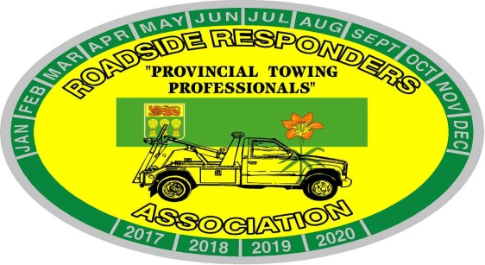

TOW SHOW EXHIBITOR REGISTRATION FORM

Industry/Company/Organization: _________________________________

Street Address:_______________________________________________

City/Town: _____________________________Province/Territory: ______

Postal Code:_____________

Telephone: _________________________________Fax: ____________

Main Contact (person who will be on site):
First Name:_______________________ Last Name:_____________________
E-mail Address: __________________________________________________

First/Last Name of second person to work at booth:
First Name:________________________Last Name:_____________________
(Please use the back side to enter additional names).

Our host hotel is the Saskatoon Inn. You make book under the RRAS Tow Show to get a discounted rate of $119.95.

All other services related to the tow show booth are the responsibility of each exhibitor. This includes but is not limited to costs such as: electricity (if additional required), water, telephone/fax, internet, shipping, storage and handling.

Once an exhibitor is registered and has provided payment, an exhibitor package of information will be provided with details and instructions on ordering and payment for additional services.

Exhibitor Space (please check):

________ Regular Booth Space @ $650 Includes: one (1) 8ft. table; two (2) chairs; 2 tickets to the Banquet

________ Outside Space @ $650 Includes: (1) 8ft. table and two (2) chairs if needed; security; 2 tickets to the Banquet. Please indicate # of units or tents you will be bringing for space design

________Both indoor and outdoor Booth space @ $1,100 includes indoor regular 8ft. table; two (2) chairs and outdoor space (table and chairs if required) to park your display; 2 tickets to the Banquet.

20 Booth Spaces Available Indoor

________Extra Banquet tickets (Saturday September 18th) @ $60

All other services related to the tow show booth are the responsibility of each exhibitor.

RRAS will have security but can assume no liability for displays.

This includes but is not limited to costs such as: electricity (if your package does not come with it), water, telephone/fax, shipping, storage and handling, excessive garbage removal.

Method of Payment (please select one)

Cheque (Enclosed)____E-transfer____Visa____MasterCard____Amex____

If paying by credit card please complete the following:

Card Number:__________________________________________

Card Holder’s Signature:__________________________________

Print name:____________________________________________

Exp (MM/YY):______________ CVV 3 Digit Code________

Payment Information:

Please submit this form with payment to the address below. If paying by cheque: Please make cheque payable to: Roadside Responders Association of Saskatchewan

Exhibitors must submit this registration form with a $100 deposit. Payment in full must be received prior to July 15th , 2021. Refunds for cancellation of booth space are refundable up to July 1, 2021, however, there will be a 10% administration fee on all refunds. No Cancellations after July 1st, 2021. If the Virus affects the ability to host the show a full refund will be given to those that book booth space.

Exhibitor Guide/Space Assignment:

The RRAS reserves the right to assign all booth numbers and location.

Confirmation: A confirmation of the receipt of your registration form and deposit will be provided within one week of the RRAS’s receipt of the form. If you do not hear back in regards to your request, please contact Jackie Klotz directly at 306-931-1221 or by email: roadsideresponderssask@gmail.com

RRAS Office Use Only:
Booth #: _____________
Type: ________________
Date Received: _____________

ROADSIDE RESPONDERS ASSOCIATION OF SASKATCHEWAN INC.
PO Box 7341
Saskatoon, Sask S7K 4J3
roadsideresponderssask@gmail.com

Thanking you in advance for participating in our first Tow Show in Saskatchewan in quite a few years. We are very excited about hosting this event and know that you will all have a successful and fun time as well.

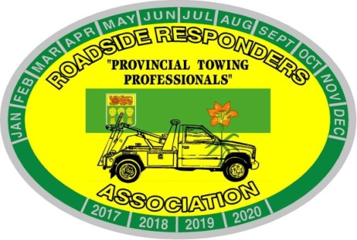
RRAS Tow Show 2021
Sponsorship Opportunities

Light/Medium Duty Beauty $150.00 1st place 2nd place
Flatbed Beauty $150.00 1st place 2nd place
Heavy Duty Beauty $150.00 1st place 2nd place
Tractor Beauty $150.00 1st place 2nd place
Voter’s Choice Award $100.00
Specialty Antique Truck
Year 2000 and older $150.00

SOLD - Welcome Reception $750.00
SOLD -BBQ and Light Show $1,000.00 6 slots at $250.00 or 1,000.00 for one sponsor
SOLD - Banquet and Entertainment $3,500.00 16 slots at $250.00 or 3,500.00 for one sponsor
There are other areas where sponsorship would be appreciated as well! Just ask us!
Please complete the above form and email to roadsideresponderssask@gmail.com or fax to 306-931-1607 as soon as possible. Sponsorships must be paid in full and sent in with the order form and are on a first come, first serve basis.
Please make cheques payable to Roadside Responders Assoc. of Saskatchewan
Box 7341, Saskatoon, SK S7K 4J3

Name of Company: _______________________________________________________
Name of Contact: _________________________________________________________
Contact Phone Number: ______________________ Fax:________________________
Email_____________________________________________________________

Credit Card Information _____Visa _____ MC ______Am Ex _____Etransfer
Card # ____________________________________________ Expiry Date:____________
Name on Card:______________________________________CVV # _______________

